REQUIREMENT SPECIFICATION DOCUMENT(SRS) for
Hall Management Center(HMC)

Team-12:INNOVATORS

Team Details:

S.NO. | NAME | ID | EMAIL
1. | Gajulapalli Sailakshmi | R200671 | gajulapallisailakshmi@gmail.com
2. | Mandi Pushpa | R200660 | pushpamandi@gmail.com
3. | Shaik Saniya Begum | R201085 | sksaniyabegum2005@gmail.com
4. | Ramisetty Manju Bhargav | R200158 | sanho8142@gmail.com
5. | Vennapusa Charan Teja | R200135 | vctr1912@gmail.com

Table of Contents:

1.Introduction

2.Purpose

3.Intended Audience
3.1.Stakeholders

4.product Vision
4.1.vision statement

5.Technologies

6.System in Context

7.Context Diagram

8.Functional Requirements

9.Non-Functional Requirements
9.1.Performance
9.2.Reliability
9.3.Usability
9.4.Security
9.5.Maintainability

10.Conclusion

1.Introduction:

This document has the requirements of Hall Management Center. The HMC tool is used by Universities. By using the HMC Tool, Universities provide a better facilities for students for their accommodation.

2.Purpose:

The purpose of this document is to gather the requirements that are needed for implementing the Hall Management Center(HMC). It also focuses on various aspects such as scope and visibility of different users ,overview on performance of different users.
The purpose of HMC is to provide efficiency to the universities in maintaining student accommodation and maintain the data of the particular student user up to the date. It provides an online visibility of the status of an user.

3.Intended Audience:

The intended audience will be Hall management administration who want to accommodate students.

3.1.Stakeholders:

Client : Hall Administrator ( Warden )
Users : individuals who use the HMC
(Student , Warden , Mess Manager , Chairman , Staff Manager)

4.Product Vision

4.1Vision Statement:

The product vision is to develop a HMC Tool, which is user friendly and easily accessible. This HMC Tool helps to manage student accommodations.

5.Technologies:
Hardware: Desktop Computers,Barcode Scanners,Printers
Software:
Frontend : HTML , CSS , JAVSCRIPT
Backend : XAMPP , MYSQL , PHP

6.System in Context:

HMC Tool is a multi user system which provides Information about student accommodation. It gets student details from the administration and also accepts queries and provide solutions. It aims to provide basic visibility to give a clarity to the personnel. It provides status of the halls to users, support personnel and administrator. It allows administrator to change the status of current halls.

7.CONTEXT-DIAGRAM:

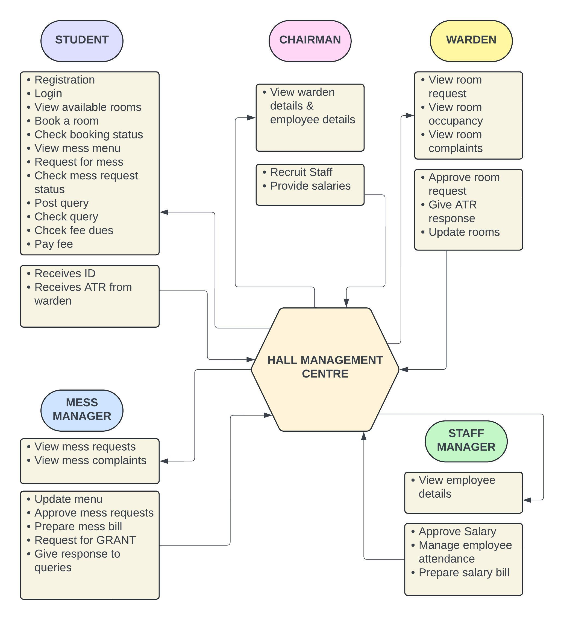

8.Functional Requirements:

- System (Hall Management Center) supports five types of people.
  - Student: Register with the basic details,Registers for rooms and halls,register for mess with selected menu,Raise complaints
  - Warden: validates room requests from student and receives room request,update room and hall details,receives complaints from student and post his ATR to each complaint,views accounts and fees.
  - Mess Manager: prepare food menu with prices,receives the mess details from student,receives and respond to the complaints from student,have visibility on administration about mess fee.
  - Chairman: Have visibility on wardens,Recruitment of staff,Distribution of funds.
  - Staff Manager: Have visibility on all other users,issues salary cheques to staff,maintain attendance details of staff,managing the staff details.
- Student Registers for the functionalities of Hall with the following details:
  - Provides his/her personal details(name,phone number,email,photo,address)
  - Register for room with selected type of room(sharing/single),amenities(reading rooms, play rooms,TV rooms etc).
  - Register for mess with selected mess menu(veg/non-veg) and prices according to them.

- Warden gets room request from student and updates the room and hall details as per student requirement. He updates the room & amenities fee which is added to the fee column of administrator page as accommodation fee.

- Mess manager gets mess registration request from student and updates the mess menu of that personnel. He updates the mess fee details of a personnel which is added to the fee column of administrator page as mess fee.

- Chairman has visibility on all other users, and has manages the recruitment of staff and distribution of funds &grant among different halls.

- Staff manager has visibility on all other users ,validates & updates the details of staff,provides monthly salary cheques to the staff.

9.Non-Functional Requirements

9.1.Performance

• The system should process room booking and viewings within seconds.
• The system should handle up to many concurrent users without performance
degradation.

9.1.2.Reliability

• The system should have an uptime of 99.9%.
• The system should perform daily backups to prevent data loss.

9.1.3.Usability

• The UI should be intuitive and easy to navigate for Hall management staff and members.
• Training material should be provided for first-time users.

9.1.4.Security

• The system should have role-based access control.
• The system should encrypt sensitive member and hall information.

9.1.5.Maintainability

• The system code should be modular and follow coding standards to ensure
maintainability.
• The system should allow easy updates to the book and member databases.
10.Conclusion:
SRS document gives information about functional and non-functional requirements of the Hall Management System.It can be further reviewed and update as per requirement and system performance.

